.

**DeptofArtificialIntelligenceandMachineLearning**|**RajalakshmiEngineeringCollege**

176

11-Exceptions

ProblemDescription:

# OutofRangeNumbers

WriteaPythonscriptthataskstheusertoenteranumber withinaspecifiedrange(e.g., 1 to 100). Handle exceptions for invalid inputs and out-of-range numbers.

.

**DeptofArtificialIntelligenceandMachineLearning**|**RajalakshmiEngineeringCollege**

177

InputFormat:

Userinputsanumber. Output Format:

Confirmtheinputorprintanerrormessageifit'sinvalidoroutofrange.

## Forexample:

|  |  |
| --- | --- |
| **Input** | **Result** |
| 1 | Validinput. |
| 101 | Error:Numberoutofallowedrange |
| rec | Error:invalidliteralforint() |

**PROGRAM**

try:

num = int(input())if 1 <= num <= 100:

print("Validinput.")

else:

print("Error: Number out of allowed range") except ValueError:

print("Error:invalidliteralforint()")

.

**DeptofArtificialIntelligenceandMachineLearning**|**RajalakshmiEngineeringCollege**

178

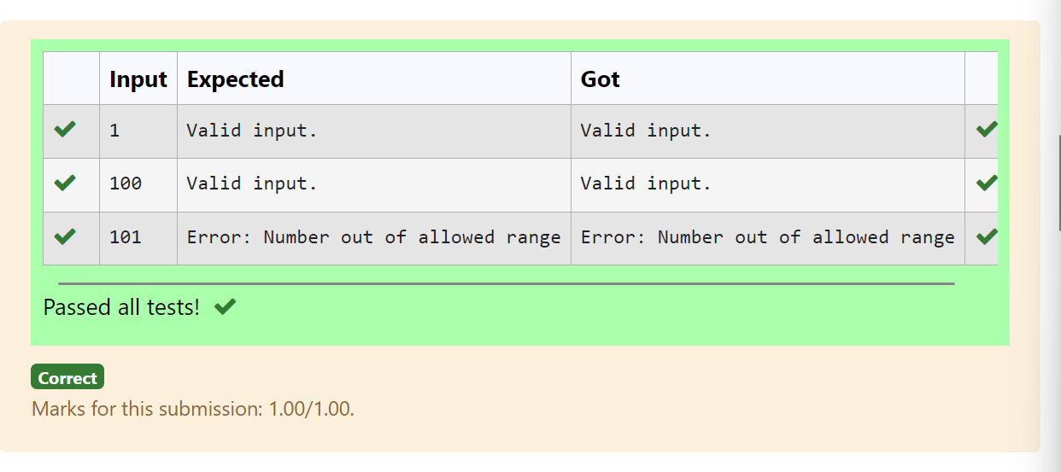

.

**DeptofArtificialIntelligenceandMachineLearning**|**RajalakshmiEngineeringCollege**

179

# DividebyZero

DevelopaPythonprogramthatsafelyperformsdivisionbetweentwonumbersprovided by the user. Handle exceptions like division by zero and non-numeric inputs.

**InputFormat:**Twolinesofinput,eachcontaininga number.

**OutputFormat:**Printtheresultofthedivision oranerrormessageifanexception occurs.

## Forexample:

|  |  |
| --- | --- |
| **Input** | **Result** |
| 10  2 | 5.0 |
| 10  0 | Error:Cannotdivideormodulobyzero. |
| ten 5 | Error:Non-numericinputprovided. |

**PROGRAM**

try:

a=int(input()) b=int(input()) print(a/b)

exceptValueError:

print("Error:Non-numericinputprovided.") except ZeroDivisionError:

print("Error:Cannotdivideormoduloby zero.")

.

**DeptofArtificialIntelligenceandMachineLearning**|**RajalakshmiEngineeringCollege**

180

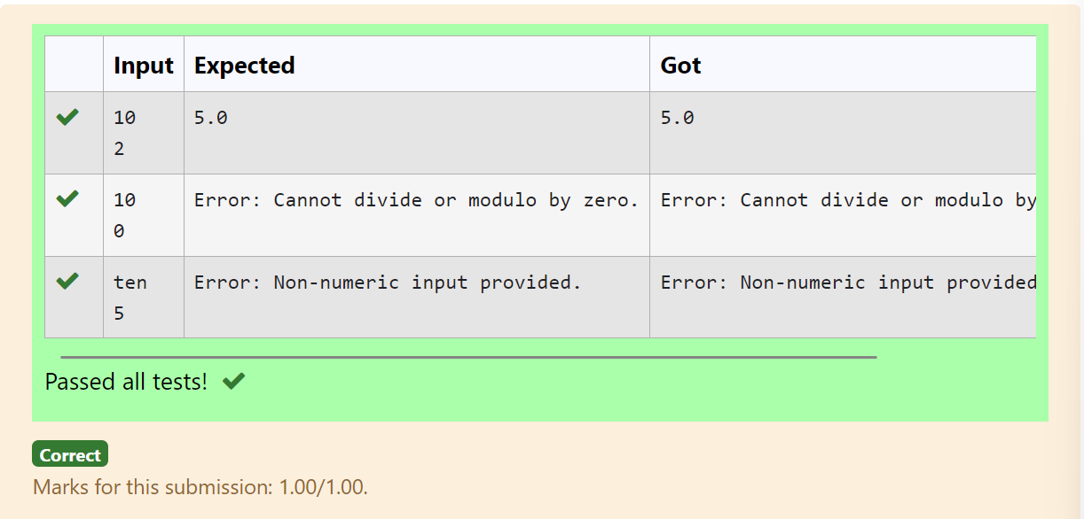

ProblemDescription:

# ValidAge

WriteaPythonscriptthataskstheusertoenteranumberwithinaspecifiedrange(e.g., 1 to 100). Handle exceptions for invalid inputs and out-of-range numbers.

**DeptofArtificialIntelligenceandMachineLearning**|**RajalakshmiEngineeringCollege**

181

InputFormat:

Userinputsanumber. Output Format:

Confirmtheinputorprintanerrormessageifit'sinvalidoroutofrange.

## Forexample:

|  |  |
| --- | --- |
| **Input** | **Result** |
| 1 | Validinput. |
| 101 | Error:Numberoutofallowedrange |
| rec | Error:invalidliteralforint() |

**PROGRAM**

try:

num=int(input())

if 1 <= num <= 100: print("Validinput.")

else:

print("Error:Numberoutofallowedrange") except ValueError:

print("Error:invalidliteralforint()")

.

.

**DeptofArtificialIntelligenceandMachineLearning**|**RajalakshmiEngineeringCollege**

182

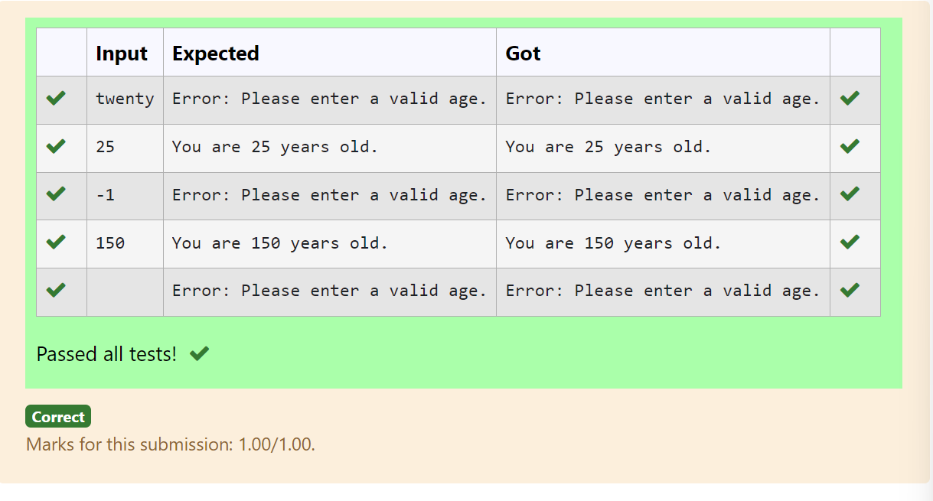

.

**DeptofArtificialIntelligenceandMachineLearning**|**RajalakshmiEngineeringCollege**

183

# SafeSquareRoot

ProblemDescription:

DevelopaPythonprogramthatsafelycalculatesthesquarerootofanumberprovided by the user. Handle exceptions for negative inputs and non-numeric inputs.

InputFormat:

Userinputsanumber. Output Format:

Printthesquarerootofthenumberoranerrormessageifanexceptionoccurs.

## Forexample:

|  |  |
| --- | --- |
| **Input** | **Result** |
| 16 | Thesquarerootof16.0is 4.00 |
| -4 | Error:Cannotcalculatethesquarerootofanegativenumber. |
| rec | Error:couldnotconvertstringtofloat |

**PROGRAM**

try:

a=int(input()) if a>=0:

print("Thesquarerootof%.1fis%.2f"%(float(a),float(a**0.5))) else:

print("Error: Cannot calculate the square root of a negative number.") except:

print("Errorcouldnotconvertstringtofloat")

.

**DeptofArtificialIntelligenceandMachineLearning**|**RajalakshmiEngineeringCollege**

184

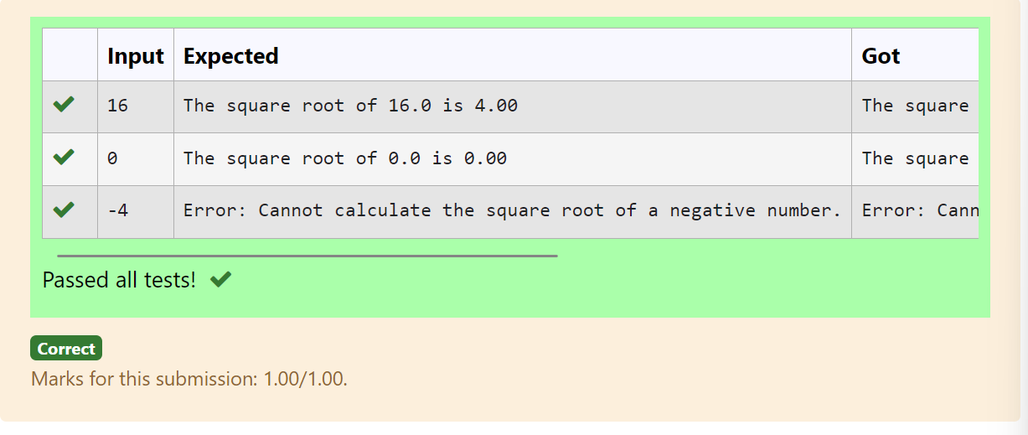

ProblemDescription:

# ValidInteger

WriteaPythonprogramthataskstheuserfortheirageandprintsamessagebasedon the age. Ensure that the program handles cases where the input is not a valid integer.

.

**DeptofArtificialIntelligenceandMachineLearning**|**RajalakshmiEngineeringCollege**

185

InputFormat:

Asinglelineinputrepresentingtheuser'sage. Output Format:

Printamessagebasedontheageoranerroriftheinputisinvalid.

## Forexample:

|  |  |
| --- | --- |
| **Input** | **Result** |
| 25 | Youare25yearsold. |
| rec | Error:Pleaseenteravalidage. |
| -5 | Error:Pleaseenteravalidage. |

**PROGRAM**

try:

n=int(input()) if n>=1:

print("Youare",n,"yearsold.") else:

print("Error:Pleaseenteravalidage.") except:

print("Error:Pleaseenteravalid age.")

.

**DeptofArtificialIntelligenceandMachineLearning**|**RajalakshmiEngineeringCollege**

186

